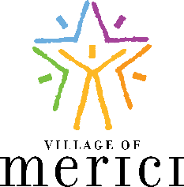
Charitable Statement of Intent
Please complete the following to advise Village of Merici of your kind gift.
Thank you for making Village of Merici a priority in your legacy planning.
_______________________________________ _______________________________________
Name Spouse Name
__________________________________________________________________________________________
Address / City / State / Zip
_______________________________ _____________________________________________________
Phone Email
⃝ I/we have made plans to leave a legacy gift to Village of Merici through my/our:
⃝ Will
⃝ Percentage of estate
⃝ Trust / Percentage of Trust corpus
⃝ Retirement Plan or IRA
⃝ Life insurance
⃝ Other Assets – Description: _____________________________________________
⃝ I/we have included supporting documentation.
___________________________________________________________________________________
⃝ Please use my/our gift where most needed (unrestricted).
⃝ Please use my/our gift for the following purpose: ________________________________________
⃝ I/we would like this gift to be anonymous.
___________________ _________________________________________________________
Date Signature
___________________ _________________________________________________________
Date Spouse Signature
Village of Merici is a 501(c)3 public charity.
Contributions are tax deductible to the extent permitted by law.
Village of Merici relies on this document for its long-term planning however, it is non-binding and may be updated at any time. Village of Merici Federal Tax ID Number is 43-2104075.
5707 E. Lawton Loop Drive, Indianapolis, IN 46216

